ANIMAL WELFARE WORKSHOP REPORT
VENUE : HELD AT SODI CENTER
DATES FROM 5TH TO 6TH SEPTEMBER 2019
TRAINERS : BAM ANIMAL CLICS .
PARTICIPANTS ; 32 PEOPLE

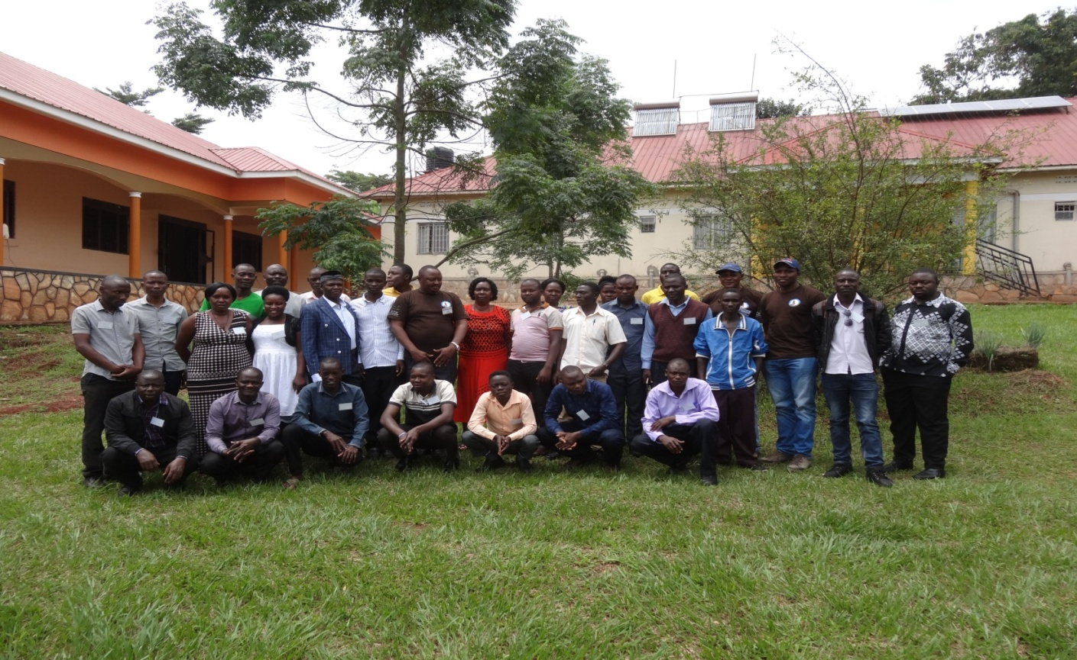

1. O Background
Green light forum Uganda is a registered non-governmental umbrella organization which operates in Hoima, Buikwe ,Wakiso, Mpigi, and Butambala districts of Uganda . It was founded by 5 non governmental organizations and 6 schools who are all partners of GLS future foundation Germany, but more two have joined the umbrella
Vision.
A healthy and educated society that is sustainably managing its environment.
Mission statement
Building the capacities of member organizations, farming and school communities, in organic agriculture, environmental management and skills development.
Strategic goal
Contributing to the improvement of livelihoods of schools and farming communities through increased food security and incomes while preserving the environment.
  - Training needs of GLFU
On the 9th /08/2019 a team from the GLFU represented by chair person and supervisor held a meeting with the BAM representatives at the GLFU secretariat. GLFU offices pointed out some of the challenges faced in the previous project phase which were meant to be addressed before the second project phase. These were some of the challenges highlighted;
- Insufficient animal husbandry knowledge coupled with insufficient government extension services reaching out to animal keepers
- Poor Conceptions, especially bull calves were produced yet the project was more interested in female calves for passing over to the next beneficiaries..
- Low knowledge about breeding and animal management which led to no meaningful realization of animal multiplication and low productivity in some animals
- Issues concerning animal welfare and health were also of great concern as most people did not observe proper animal welfare practices which lead to low production.
- Low knowledge in procurement of right breeds for milk production.
- Diseases like ECF, trypanosomiasis, and mange in rabbits which are very expensive to treat in some cases attacked the animals.
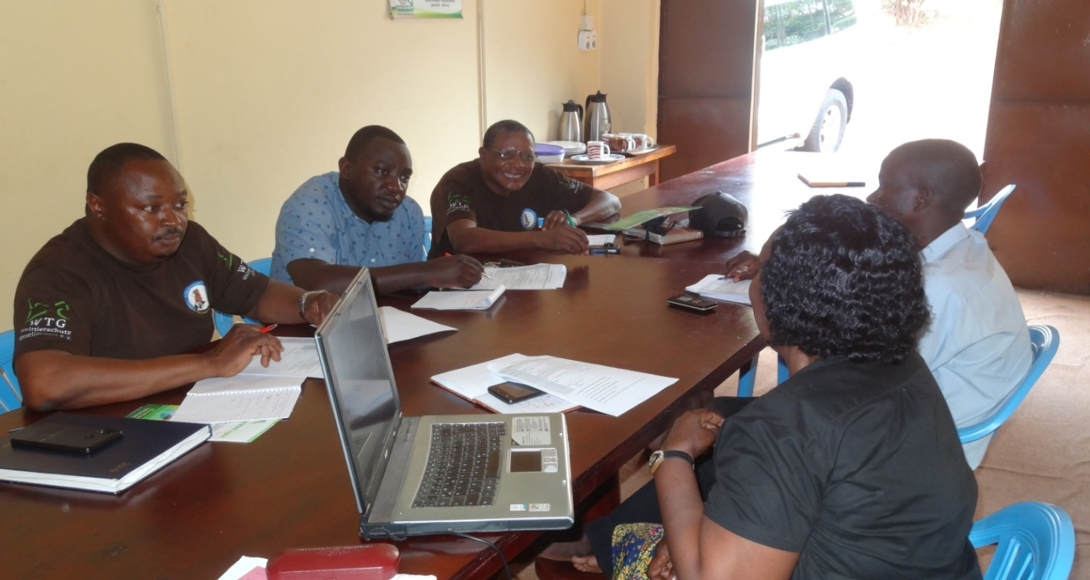

Above : Bam vets in a preparatory meeting with the chairperson and supervisor of green light forum at GLFU secretariat .
2 Training topics:
After the meeting, BAM came up with relevant topics for training field personnel to equip them with skills to address the challenges raised in the discussions and these were;
- Animal care
- Animal welfare Five freedoms
- Clinical examination
- Ectoparasites and endoparasities
- Hygiene and Infectious diseases
- Wound management
And based on that they developed the training programme bellow.
TRAINING WORKSHOP PROGRAM /SCHEDULE
 | Theory | Practical
Day 1  5th/09/2019  Morning  Afternoon | Welcome and Introductions  Animal Welfare – Five Freedoms  Animal Care | - Questions Animal Welfare  - Questions Animal Care  Exercise food types sheet
Day 1  5th/09/2019  Morning  Afternoon | Animal Welfare/Care Cases - Assessment of different systems of animal husbandry according to the five freedoms  Activities
Day 2  6th/09/2019 | Clinical Examination | - Questions Clinical Examination  - Body system-fill-in-sheet
Day 2  6th/09/2019 | Clinic  - Handling and restraint of different species with and without tools,  - Clinical examination of different animals  Activities: samples of all locally domesticated animal species for the course – practical exercises.
Day 2  6th/09/2019 | Clinic: Examination and treatment for different parasites depending on availability.  Activities: Animals with parasites will be available on site – training theory in practice
 | Hygiene and Wound Management | - Questions on Wound Management  - Short films: foot bandage, head bandages etc.
By the end of the two days, it was realized that all topics were very important to all the trainees.
The trainees pointed out that the five freedoms and animal care were the most important topics in the workshop and promised to apply the skills acquired on the farms and communities to improve on animal production and reproduction.
3 methodology of training.
The workshop started with registrations by all members who participated, then prayers and self-introductions. Mr. Balondemu led the participants through workshop Norms and expectations. It was at this time that leaders were selected including the Course leader, The Time keeper and Welfare in charge.
The chairperson Miss Nankya Proscovia welcomed everyone in the meeting and thanked the Bam team for turning up to train field staffs. She said the participants comprised of five local NGOs found in various parts of the country and 8 schools. She sighted the reasons why this workshop was a must and timely to help the partners prepare for the new stock of animals soon to come with the next BMZ project .
The methodology of training included; presentation by BAM team, group work and discussion, and practical demonstrations.

3.1. Presentation.
Animal welfare – Five freedoms by Mr. Kagoda Samuel:
He discussed the five freedoms in animal welfare like; freedom from hunger and thirst, freedom from discomfort, freedom from pain, injury and diseases, freedom to express normal behavior and freedom from fear and distress. He further emphasized that one freedom should not compromise on the other freedom. He went on to discuss the welfare and stress response, measuring stress and indicators of poor welfare like stereotypes, redirected behaviors and self-injuring behaviors.
Lastly he discussed assessing animal welfare situation, Anthropomorphism, The role of the participants in animal welfare and the role of the community in animal welfare. The model of presentation was very good and all trainees properly understood their roles in improving animal welfare
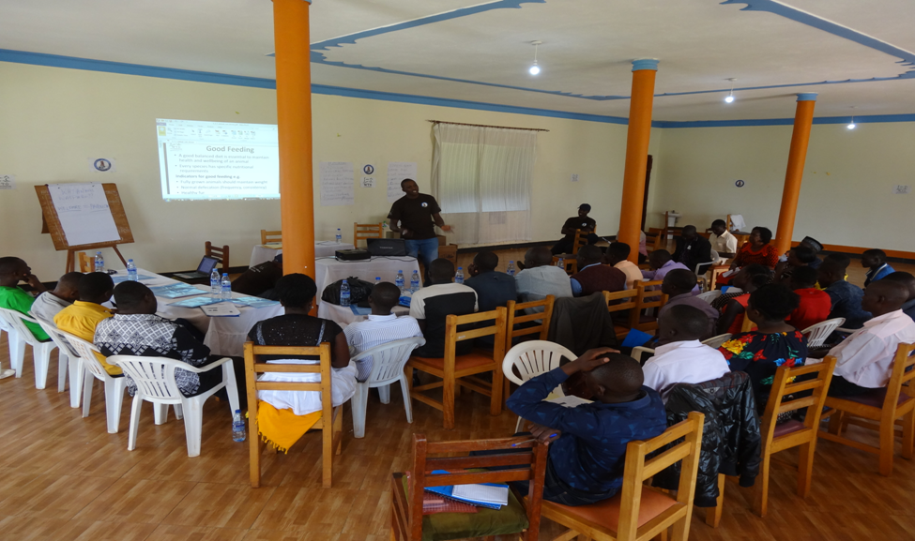

Above : Mr kagoda presenting and facilitating the discussion of five freedoms
Animal care; (Dr Tayebwa Dickson)
Dr. Tayebwa clearly explained the various aspects of Animal husbandry and he mentioned; good housing, good feeding and good care. In each category, emphasis was put on Dairy cows, Piggery, Poultry, Rabbit production and Goats raring.
Participants were guided on how to make appropriate housing structures for the mentioned animal species and emphasis was mainly on Space, protection from Sun, Wind and Rain. Elements of good hygiene were emphasized. He further discussed feeding and the effects of underfeeding and overfeeding as manifested by the body condition score.
Feeding and Care were extensively discussed and participants actively engaged in asking various questions about feeding of especially Rabbits, dairy cows and piggery.
Clinical examination by Dr Tayebwa Dickson He explained different components of clinical examination which includes: Signalement; Emphasized the need for one to have in mind the; Species, Breed, Age, Sex Special marks during diagnosis. All these were discussed extensively. Patient history; Types of symptoms; Acute or chronic, Cause of disease; care; nature of feeding; housing; change of environment. All those were discussed extensively.
General clinical examination; Elements of Adspection , Palpation, Percussion , Auscultation , Body temperature, Mucosa capillary refill time and Skin Turgor test were all discussed. Specific clinical examination; He explained the importance of considering the various systems of the body while making clinical examination. This was followed by practical. Note. All the facilitator from BAM presented well using simple example easily understood by the participant but the time for the training was limited yet we had to learn a lot of issues concerning animal welfare of various types.
3.2. Group work and Discussions; Four groups were formed each with 8 members and every group was given a different farming system to discuss. They included; Intensive farming, semi intensive, Extensive, Organic farming. Each group selected a representative to present their findings. He/she defined and discussed the advantages and disadvantages of each farming systems. By the end of this session, participants highly appreciated the importance of organic farming system as it addresses the five animal welfare freedoms.
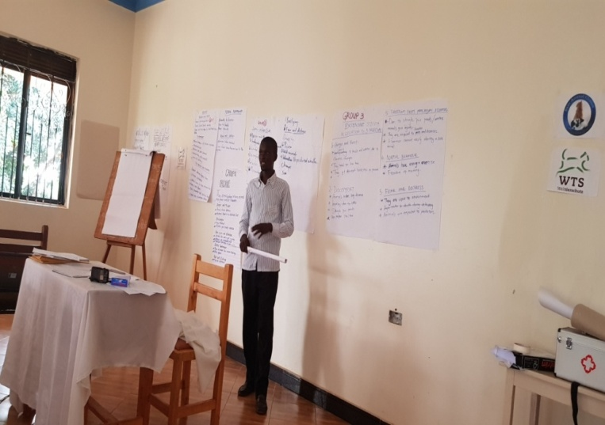

Above : one of the participants presenting group findings
3.3. Field practical
The participants were taken out for practical, trained on handling of different animal species like chicken, dairy cows, Fish , Pigs , Goats and Dogs. Dr. Tayebwa Dickson emphasized that the owner of an animal is always very helpful during handling and restraint. Ageing of the animal is key in physical examination as farmer’s records may not be accurate.
Participants were shown several instruments used for different diagnostic procedures and discussed several drug interactions with practical demonstrations. The facilitator demonstrated how to handle chicken, feeding, culling, diseases control, hygiene, eggs management.
Second was the cows; Dr.Tayebwa and other Facilitators practically demonstrated how to carry out pregnancy diagnoses in cows, determine age, Diagnosis by palpation, percussion Handling (Restraints), Dosing, treatment sites, management of drugs, administration, etc.
Third was Piggery production; we visited a piggery unit and Dr Tayebwa demonstrated how one would restrain a pig before examination and may be subsequently treat. Feeding, clinical examination aspects were all done practically.
Participants learnt a lot about goats handling, clinical examination and treatment techniques. In all cases, the participants actively participated in handling and restraint of animals for examination.

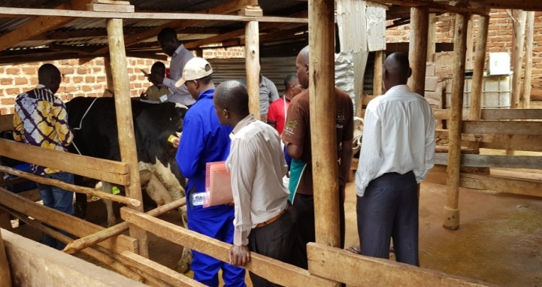
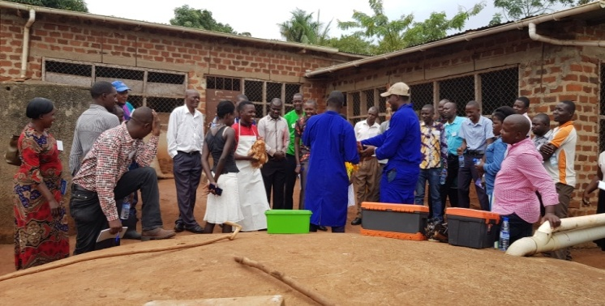

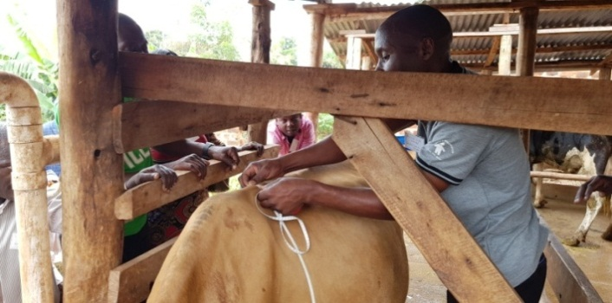
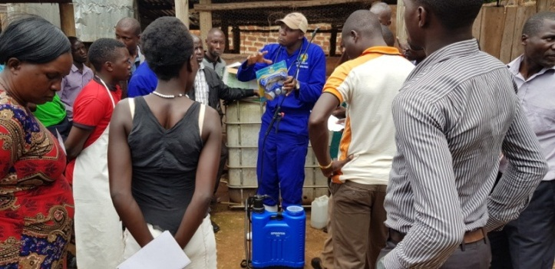

Above: trainees undergoing practical training at SODI farm
The participants practically learnt how to mange and treat wound in animals using a dog which had a deep and septic wound due to bite by another dog . All the participants and Dr. Dickson did wound assessment, used blade to remove hair, did local anesthesia, found out the wounds were mechanically inflicted and had been on for several days, were wide and contaminated. We removed all the foreign materials, cleaned with saline and applied a solution of Iodine to disinfect it. Iodine was a good choice because it is of broad spectrum. We then sprayed with wound aerosol and injected with Strepto-pen. Finally we gave Ivermectin. Dr. Dickson told participants to always follow those steps well when treating animal wounds.

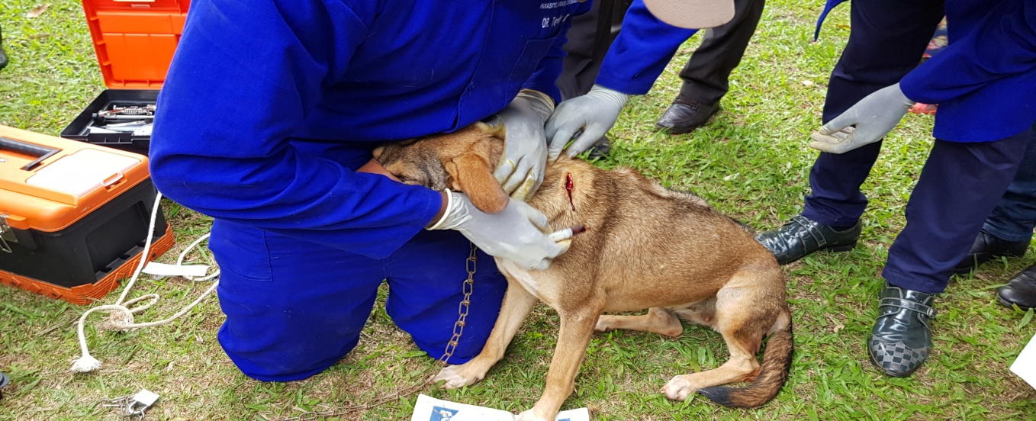

Above : The wounded dog of SODI undergoing treatment .

4. Training outcomes
All GLFU partners were represented and participated in the training and got certificates after the training.
BAM animal clinics had experienced and technical staff who properly trained GLFU staff.
Participants acquired practical skills in animal Welfare and management.
All discussed topics were very important especially for the second project phase.
5. Recommendation/ topic for further training.
Each partner should be given tools and equipment to use in simple clinical examination, diagnosis and treatment.
Members request for further more elaborated training in the following areas;
- Proper breed selection, animal feeding and general management.
- Detailed training in management of fish ponds and fish feeding through different stages
- Reduction of mortality rates in animals like piglets, calves, chicken, rabbits etc.
- Detailed training in poultry management like brooding, feeding, treatment.
- General apiary Knowledge.
6. Conclusion.
In conclusion the workshop was very important to GLFU partners as it helped staff to acquire practical knowledge in animal welfare
The BAM animal clinics staffs are so experienced in animal husbandry and recommend them for further training in the same field to boost partners expertise and improve on animal production and reproduction.
Lastly we are so great full for the opportunity provide to GLFU family GLS future foundation and promise to make good use of the knowledge acquire . Thank you so much GLS.
Compiled by : Yokolamu Balyejusa – supervisor BMZ project

